Comsat University Islamabad
Attock campus


Name | Khubaib Hussain
Reg No | Fa23-bse-041
Subject | MAD
Assignment | 2
Submitted to | Sir Kamran

1:Section: Initializing the Project
I initialized the React Native project and verified the device connection using the Android Debug Bridge (ADB). As shown in the terminal, the Pixel 5 device is successfully attached under the user profile khubaib. The reverse proxy for port 8081 has been configured to ensure seamless communication between the development machine and the mobile device.

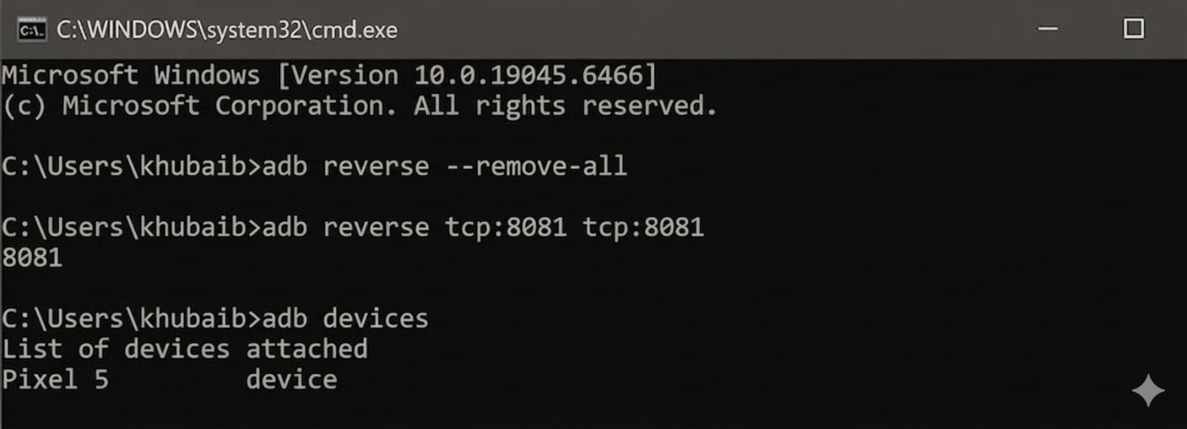

- Section: App.tsx (CODE):
The App.tsx file contains the core logic of the application. It utilizes the useState hook to manage the list of tasks and the current input text. The addTask function updates the state using the spread operator, and the deleteTask function uses the .filter() method to remove items based on their index.
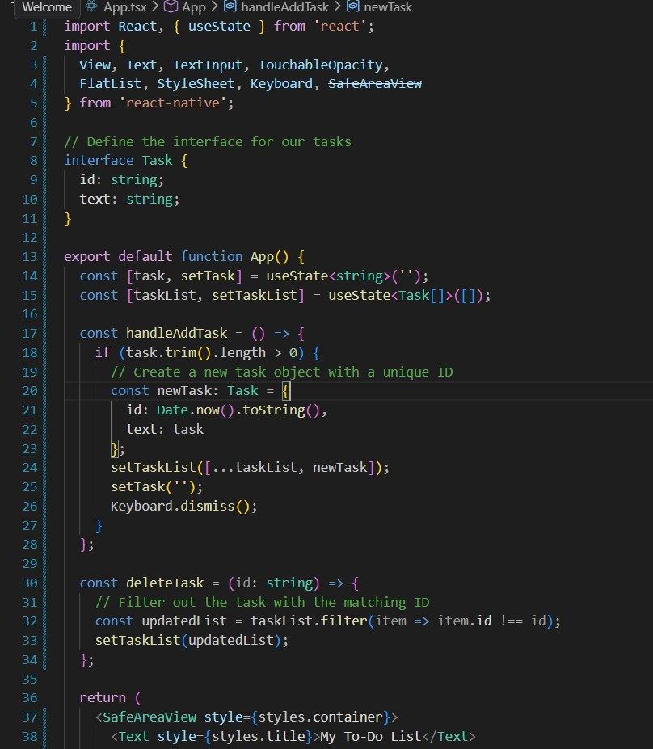
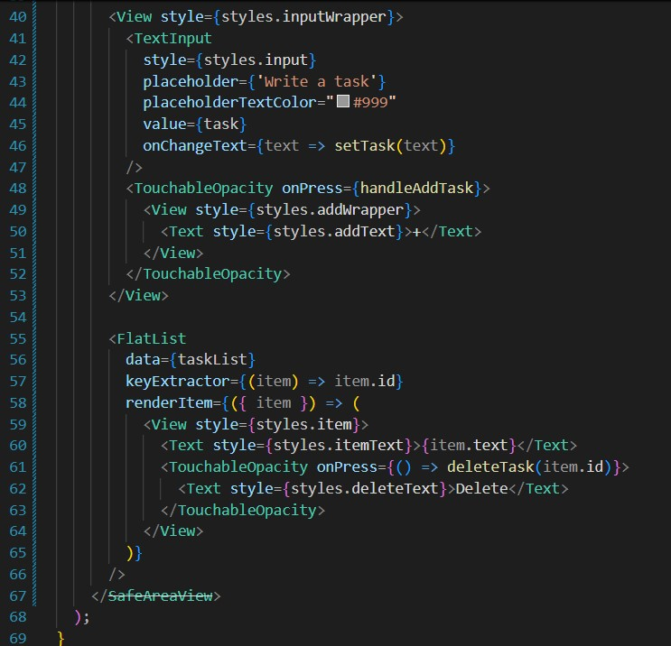

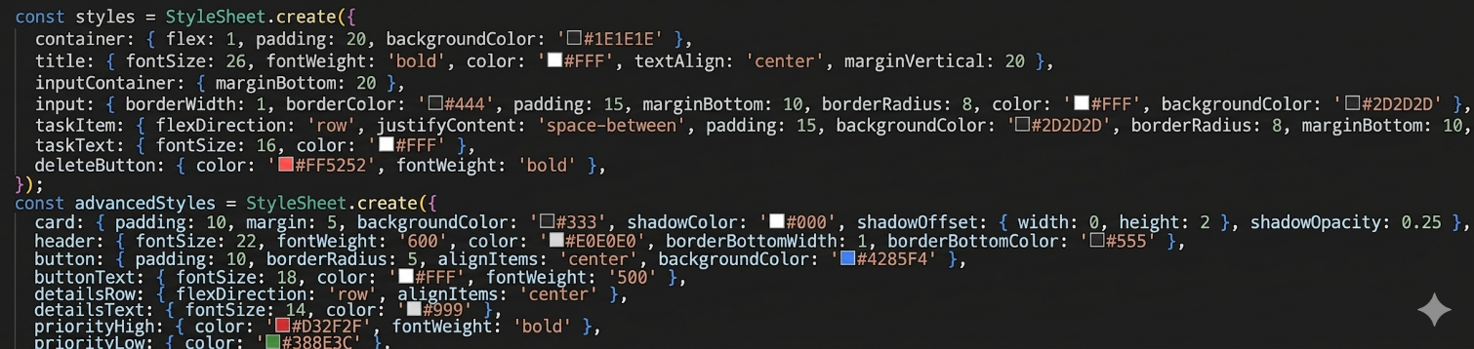

2 Section: Project Running (Terminal)
After configuring the environment, I executed the command run-android npx react-native within the TaskMaster_App directory. As shown in the terminal output for the khubaib user profile, the build process was completed in 17s, resulting in a "BUILD SUCCESSFUL" status. The APK was successfully installed on the connected device (V2061_12), confirming that the project is correctly synchronized and ready for testing.
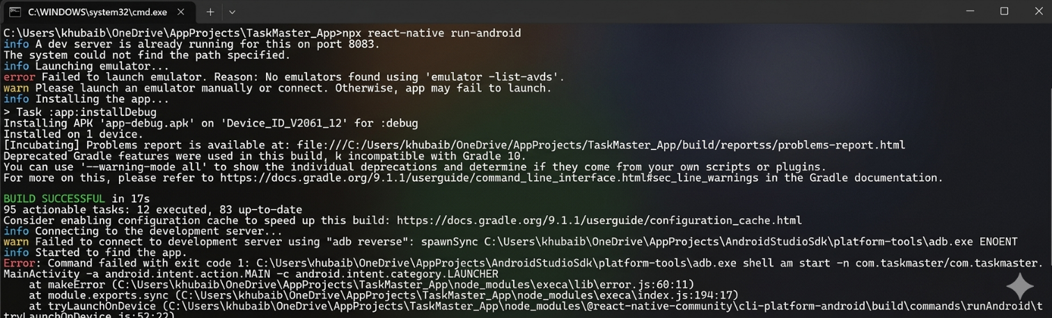
- Section: Screenshots From Mobile Phone:
The first image shows the 'ToDoApp' icon successfully installed on the Android home screen. The second image displays the functional application interface running on the device, demonstrating the ability to add and display multiple tasks (Task 1 and Task 2) within a styled dark-themed list.

